Christian Rooks

Digital Forensics in Cybersecurity - D829

11/19/2025

TQN1 Task 1: Collecting and Analyzing Forensic Evidence

A. Introduction

A.1 Purpose of the Report:

This‍‌‍‍‌‍‌‍‍‌ document is intended to provide a thorough formal account of the confidential data breach incident, which is the primary concern at ABC Tech regarding the unauthorized access part and the potential falsification of crucial files. The present report is an instrument to ascertain if security measures within the company were circumvented, to find out the ways hackers used to gain access, and to recognize the exact extent of the breach. The real facts disclosed in this document are the basis for the planned work in fixing the issue and strengthening internal security ‍‌‍‍‌‍‌‍‍‌measures.

A.2 Scope and Objectives of the Investigation:

The scope of this investigation is a formal, host-based forensic analysis limited exclusively to the suspected Windows 11 workstation. The focus is to collect and analyze digital artifacts from this single host to reconstruct the sequence of unauthorized activity and determine the full extent of the compromise.

The primary objectives of this forensic investigation are to:

1. Extract deleted files and documents from user directories

2. Analyze system event logs to identify suspicious activity

3. Recover browser activity artifacts, including cookies and cached files

4. Generate a forensic report detailing the findings

1.3 Tools and Methodologies Used

The investigation adheres strictly to the industry-standard forensic process (Preparation, Collection, Examination, Analysis, and Reporting). The methodology employed is focused on host-based artifact recovery and reconstruction. Key tools and techniques include:

• Forensic Acquisition and Imaging: Utilization of a Hardware Write Blocker and industry-standard forensic imaging tools to create a cryptographically verified, bit-for-bit copy of the Windows 11 workstation's hard drive, ensuring evidence integrity.

• Digital Forensic Software: the use of specialized commercial and open-source forensic suites like Autopsy, and FTK Imager, for deep artifact analysis, file carving (to recover deleted files), and timeline reconstruction.

• Host-Based Artifact Analysis: Specific methodologies applied to examine the Windows Registry, NTFS metadata, Windows Event Logs, and system files and Prefetch files for evidence of user and program execution activity.

• Log and Metadata Correlation: Correlating Windows Event Logs with file system timestamps and browser history logs to establish a definitive timeline of unauthorized actions.

B. Legal and Regulatory Framework:

The‍‌‍‍‌‍‌‍‍‌ ABC Tech digital forensics investigation concerning a possible internal breach is regulated by a comprehensive framework composed of local laws, standards, and the company's own policies. This guarantees that the entire evidence gathering process is done in a lawful, ethical way and is forensic sound, making it acceptable in any future court or disciplinary ‍‌‍‍‌‍‌‍‍‌procedure.

B.1 General Laws and Regulations:

Internal breach investigations involving unauthorized data access typically fall under several key categories of legislation, particularly those related to data privacy and financial controls. This includes Data Protection Regulations such as the General Data Protection Regulation (Regulation (EU) 2016/679, 2016) or the California Consumer Privacy Act (Cal. Civ. Code § 1798.100 et seq., 2023),‌‍ ‍‌‍‌‍which require the detection and reporting of incidents within a certain time frame if the investigation is related to Personally Identifiable Information. Additionally, if the breached data contain Protected Health Information or financial consumer data, the investigation should adhere to the requirements of Sector-Specific Laws such as the Health Insurance Portability and Accountability Act (HIPAA, 1996) and the Gramm-Leach-Bliley Act (GLBA, 1999). Moreover, in case ABC Tech is a corporation listed on the stock exchange, it is also necessary to comply with the Sarbanes-Oxley Act (Sarbanes-Oxley Act of 2002) to maintain the trustworthiness of financial data and reporting systems during the ‍‌‍‍‌‍‌‍‍‌examination.

B.2 Industry Standards and Best Practices:

To ensure the technical soundness and defensibility of the findings, the forensic analysis is conducted in alignment with established global industry standards and best practices. Key among these is NIST Special Publication (SP) 800-86, which provides clear recommendations for integrating forensic analysis into an overall organizational incident response capability, governing the process from initial collection through final analysis (Kent et al., 2006). The‍‌‍‍‌‍‌‍‍‌ worldwide standard ISO/IEC 27043:2015, which outlines the principles and procedures for investigating incidents and handling evidence in order to maintain consistency, repeatability, and legal correctness, is the main document that supports this method (International Organization for Standardization & International Electrotechnical Commission, 2015).

B.3 Organizational Policies Governing the Investigation:

The‍‌‍‍‌‍‌‍‍‌ power to perform this forensic examination as well as the rules for the employees to follow have been taken solely from ABC Tech's internal documentation. The IRP, as a key policy instrument, is the source of formal authorization for the probe, it specifies the forensic team's roles, and it describes the necessary steps to be followed for the stages of containment, eradication, and recovery. The AUP is the source of the investigation's legal basis for the search of the employee's Windows 11 workstation. It states that devices owned by the company are subject to monitoring and investigation for the purpose of protecting corporate ‍‌‍‍‌‍‌‍‍‌interests. Finally, Data Retention and Handling Policies guide the classification of the compromised data and establish the mandatory period and secure methodology for retaining the evidence once the investigation is complete.

B.4 Professional Evidence Handling and Documentation:

It‍‌‍‍‌‍‌‍‍‌ is crucial that the integrity and admissibility of digital evidence are maintained throughout the investigation. This necessitates compliance with stringent professional standards, foremost among which is a full Chain of Custody record that tracks every person, time, place, and reason throughout the life of the evidence to be used as a defense against tampering allegations. Also, it is very important that a cryptographic Hash Verification be done right after the forensic image of the Windows 11 hard drive is obtained. The hash on the source media and the one on the image should be identical. This proves that no changes have been made to the digital evidence since it was collected, thus meeting one of the main requirements for the evidence to be accepted in court. In the end, and as per the least disturbance principle, the examination is carried out only on the Forensic Working Copies and not on the original source or the master ‍‌‍‍‌‍‌‍‍‌image.

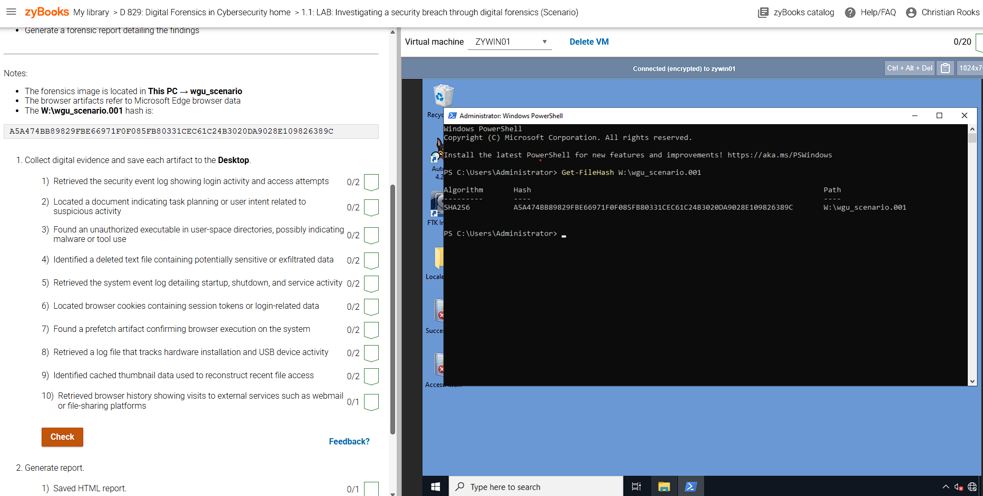

Verified The Hashes Matched to ensure integrity.

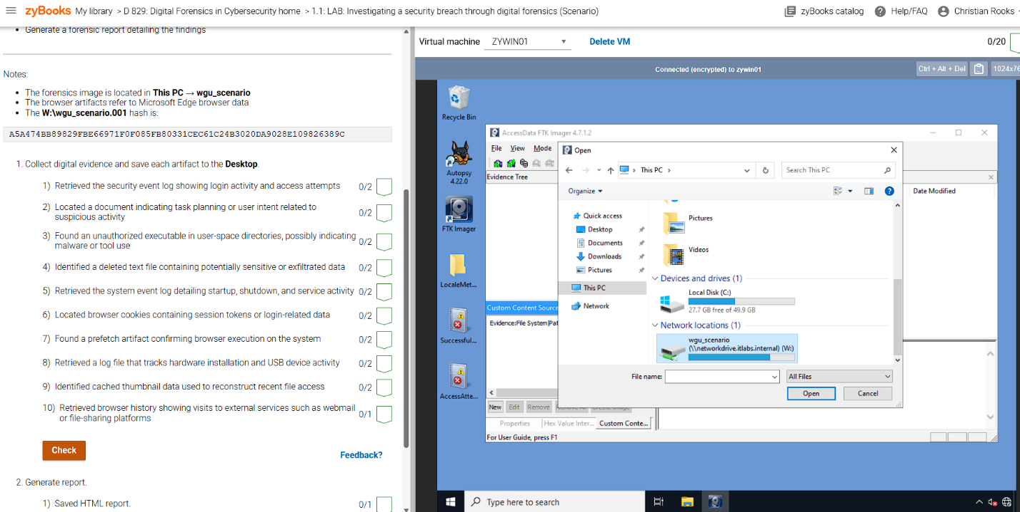Hashes matched, so I closed Powersehell.

Opened FTK Imager, then selected File, Add Evidence Item, Selected ‘Image File’ as source, clicked ‘Next’, clicked ‘Browse’, and went to ‘This PC’-‘wgu_scenario’ and clicked ‘Open’.

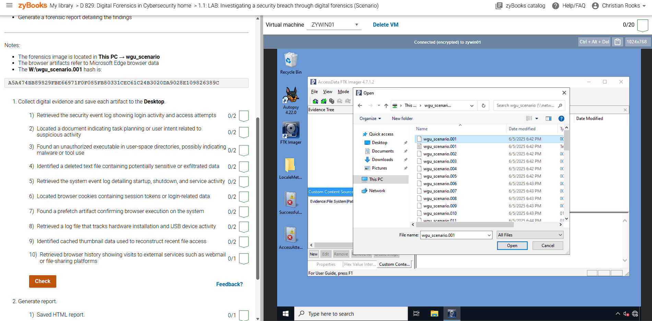

I opened ‘wgu_scenario.001’, and hit ‘Finish’.

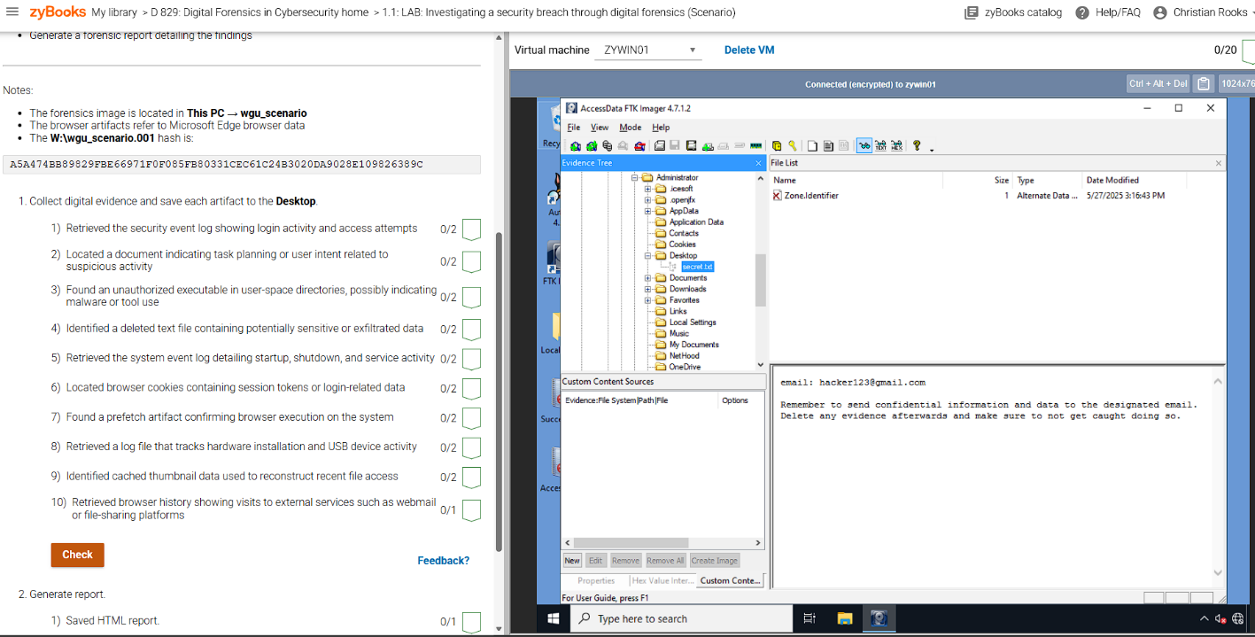

Next, under the ‘Evidence Tree’ panel, I clicked the ‘+’, and expanded ‘wgu_scenario.001’. I then selected ‘Basic Data Partition-Windows-Root-Administrator-Desktop’, and then clicked the ‘secret.text’ document. The contents were then displayed. ‘Zone.Identifier’ displays a red x, meaning this file is deleted, and I must retrieve it. At this point I close FTK Imager.

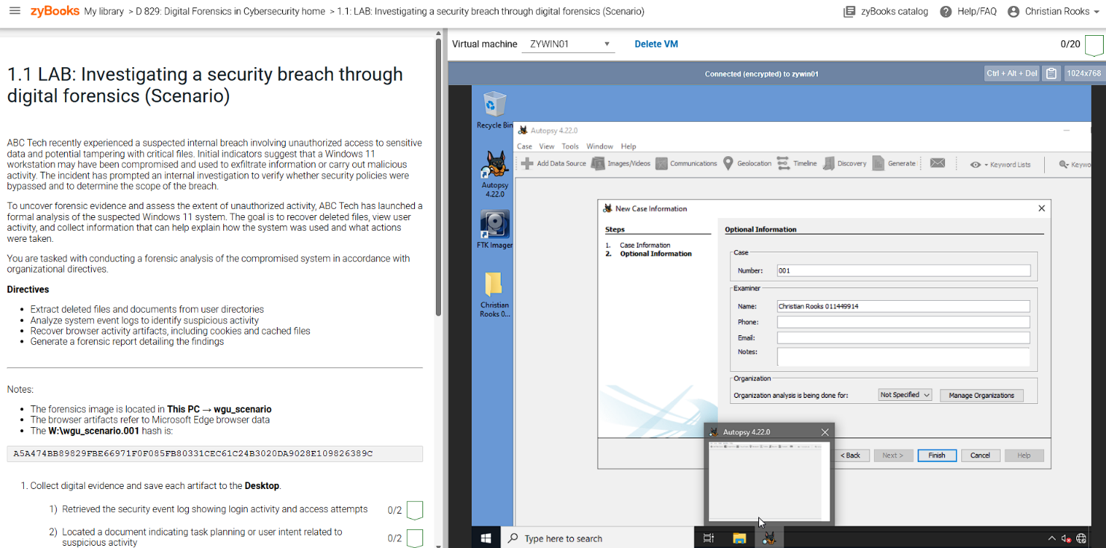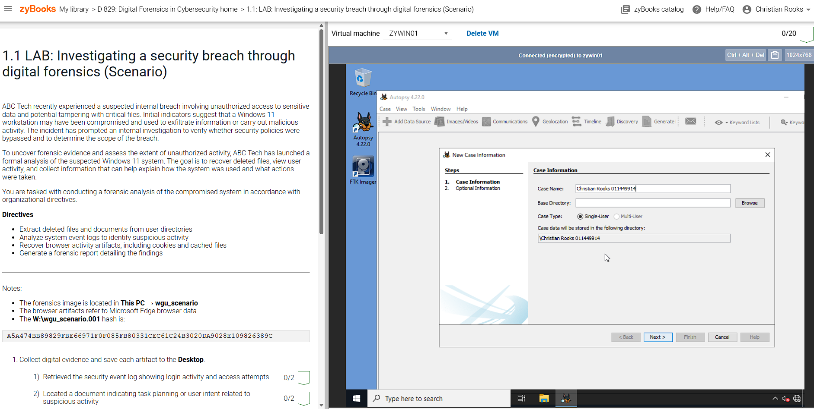I open Autopsy 4.21.0, and start a New Case named: Christian Rooks 011449914 (My name and student ID #). For Base Directory I click ‘Browse’, select ‘Desktop’, and then click ‘Next’.

For ‘Number’ I entered 001, and for name I entered: Christian Rooks 011449914. I then click ‘Finish’.

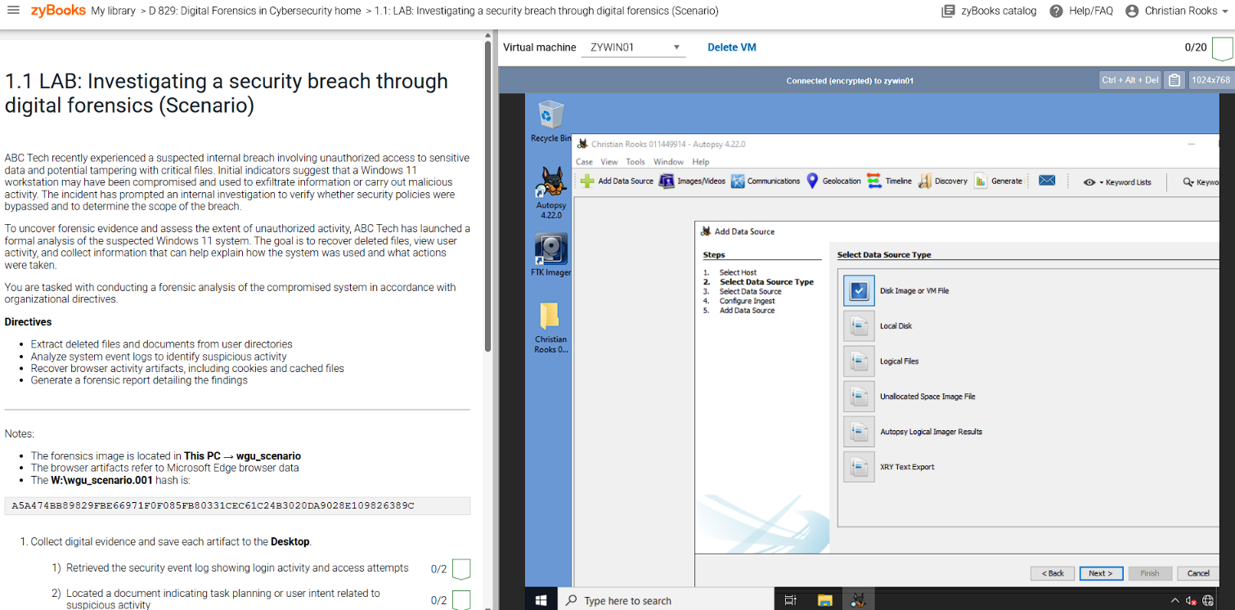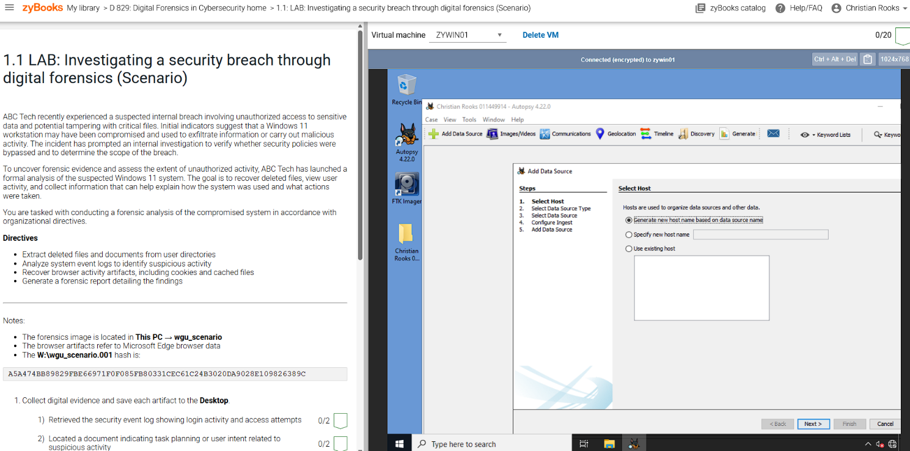I select ‘Generate New Host Name Based On Data Source Name’ and click ‘Next’.

I select ‘Disk Image or VM File’, and then Click ‘Next’.

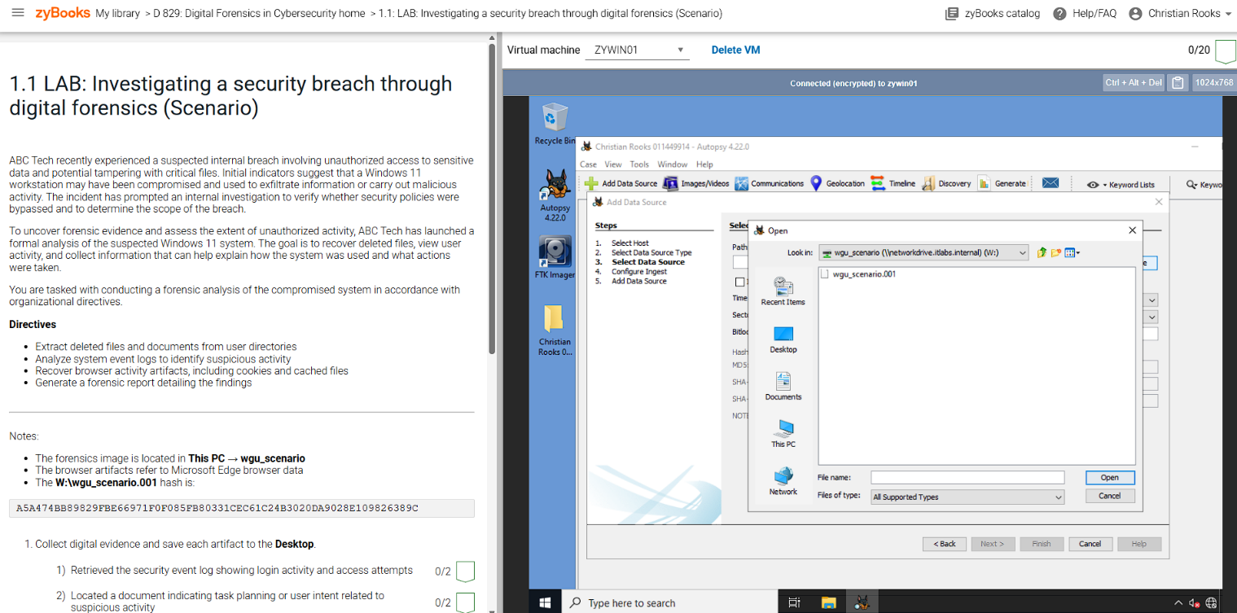In Data Source Path, I select ‘Browse’, ‘This PC’, and on the left pane, I select ‘wgu_scenario’, and I open ‘wgu_walkthrough.001’. And then ‘Next’.

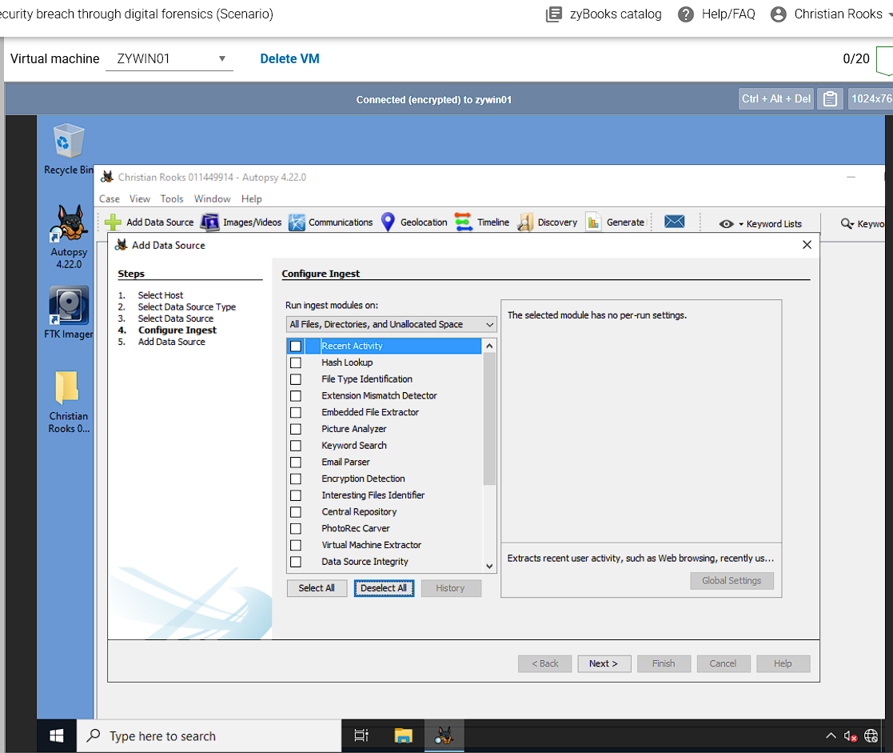

I click ‘Deselect All’, and then click ‘Next’. Once Autopsy is done, click ‘Finish’.

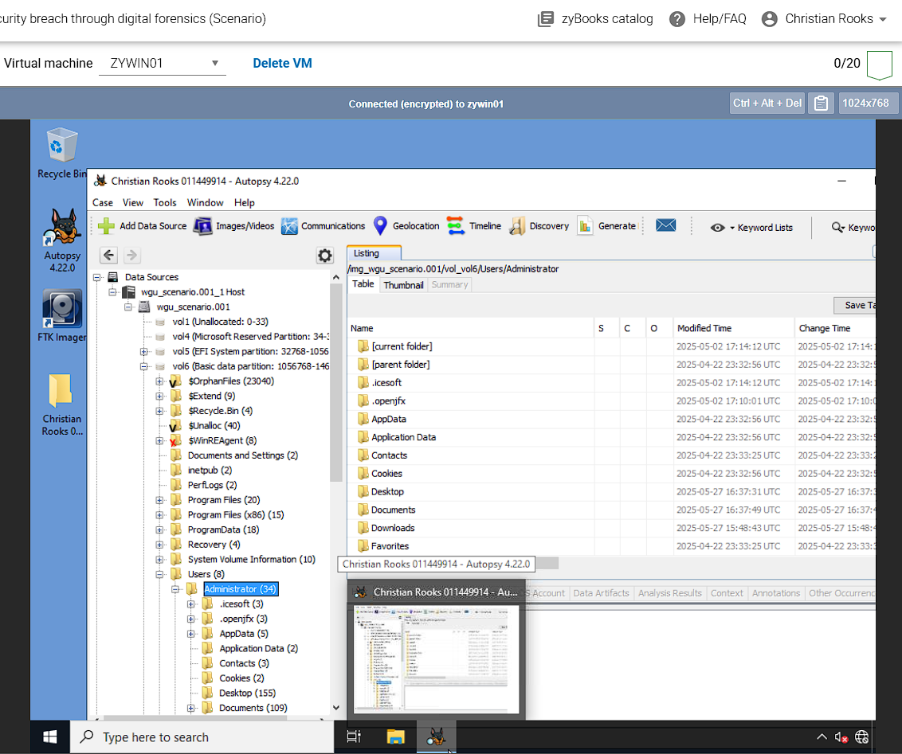I went to ‘Data Sources-wgu_scenario.001 Host-wgu_scenario.001-vol6-Users-Administrator’.

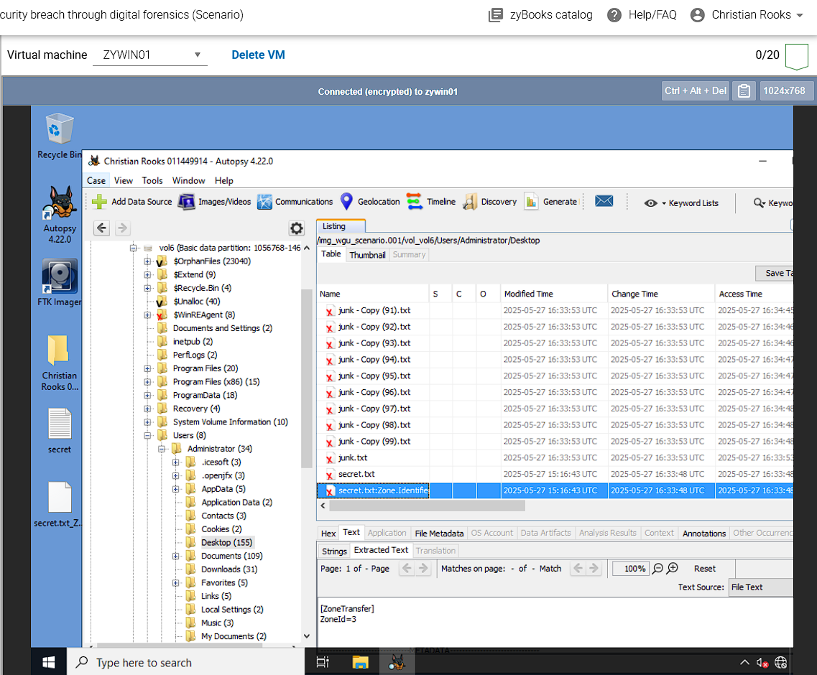

I selected ‘Desktop’, and right-clicked secret.txt, and secret.txt:Zone.Identifier, and selected ‘Extract Files’, and saved to ‘Desktop’.

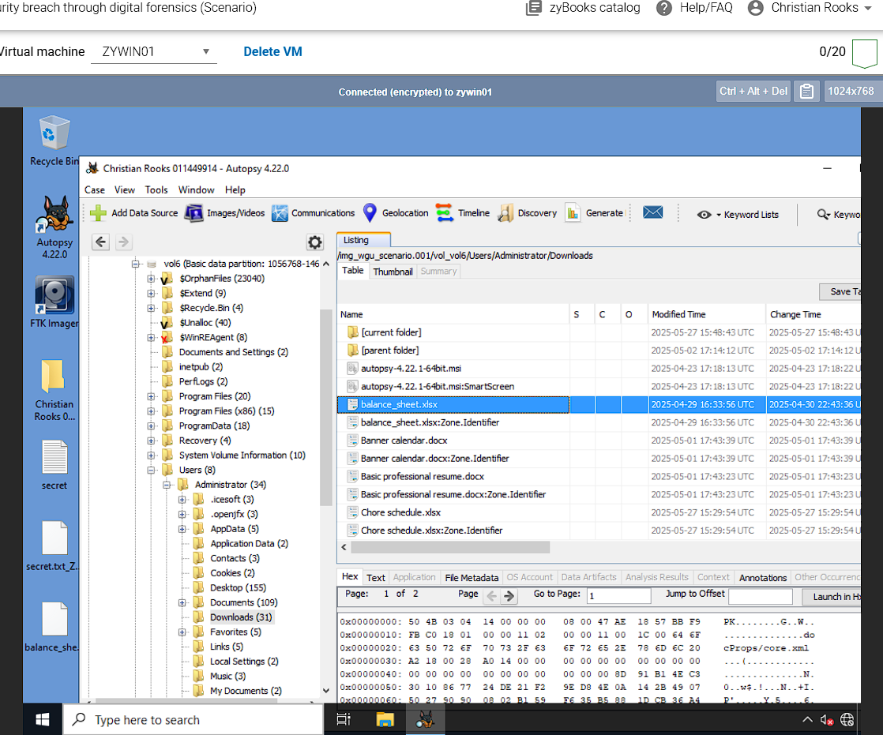

I select ‘Downloads’ in the left pane, and right-click ‘balance_sheet.xlsx’ and ‘Extract Files’ to ‘Desktop’.

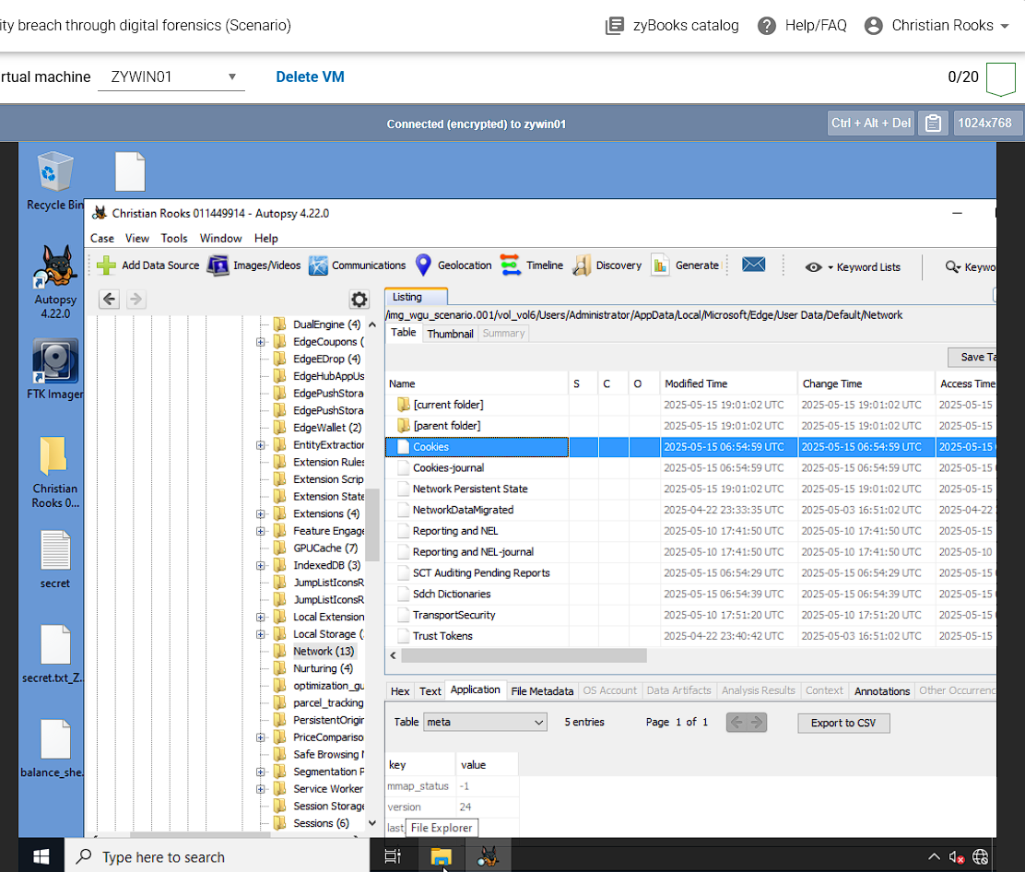

I went to ‘Users-Administrator-AppData-Local-Microsoft-Edge-User Data-Default-Network’, I click on ‘cookies’, and Extract Files to ‘Desktop’.

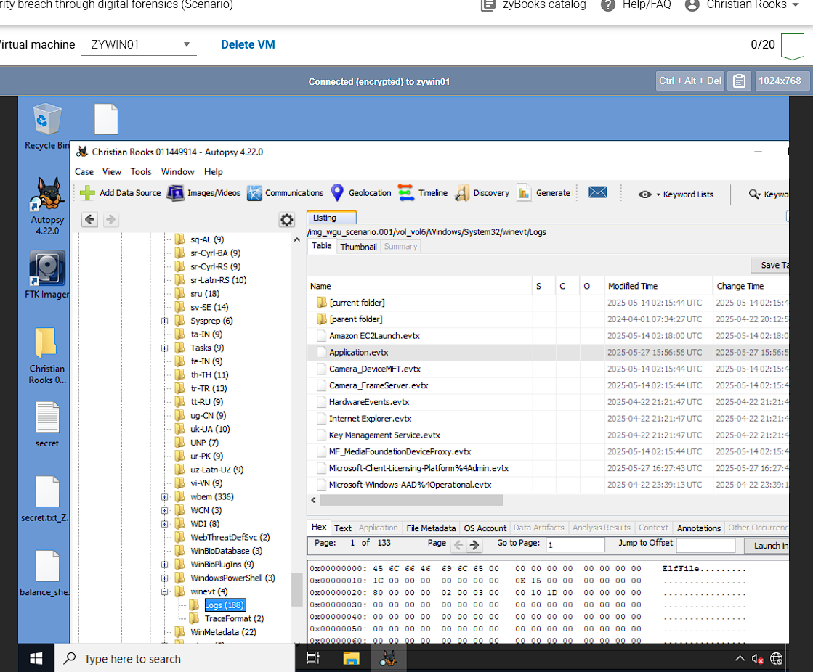

I went to ‘Windows-system32-winevt-logs’, clicked ‘application.evtx’, and Extracted Files to ‘Desktop’.

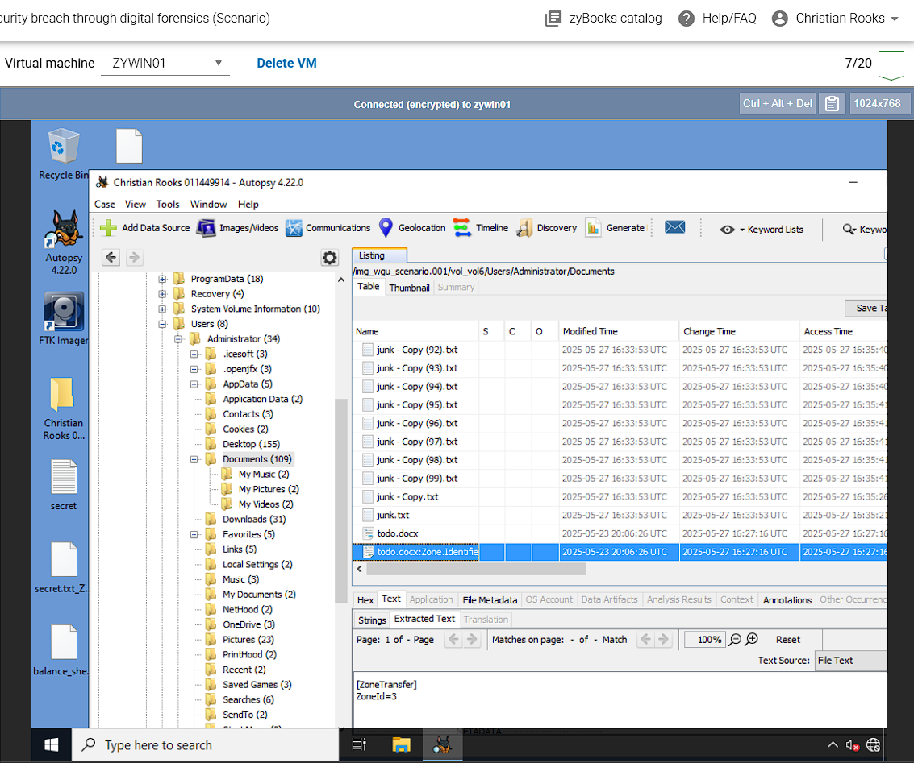

I went to ‘Administrator-Documents’, found ‘todo.docx’, Extracted Files to ‘Desktop’.

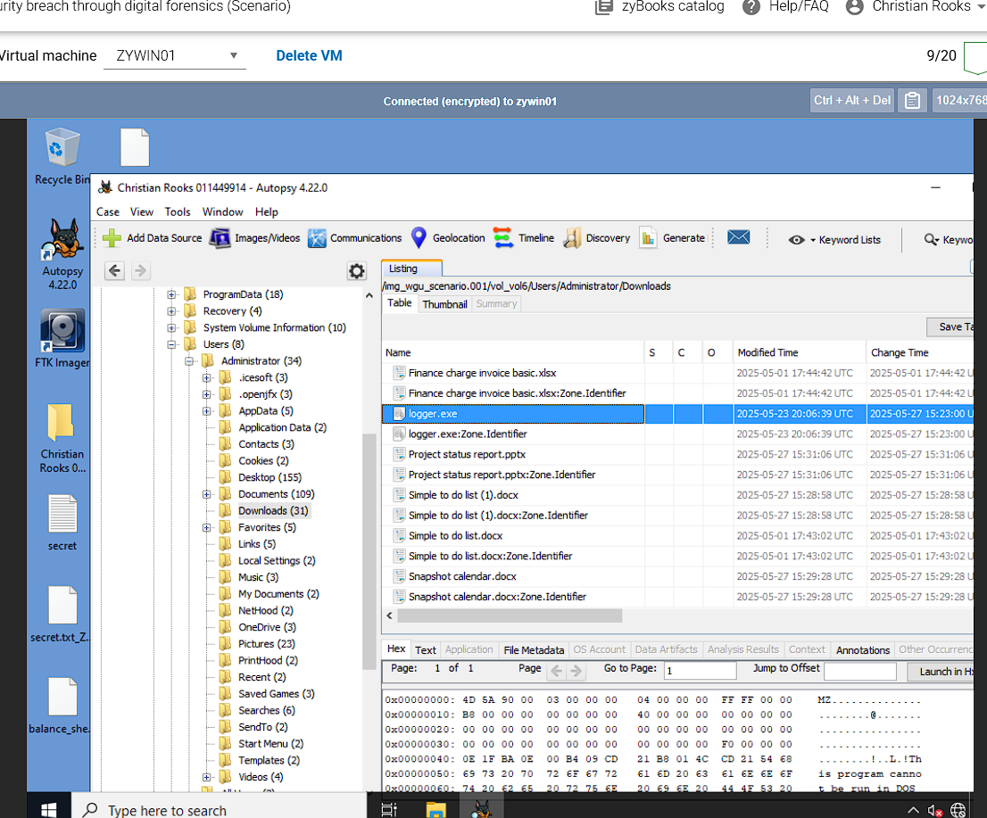

I went to ‘Administrator-Downloads’, found ‘logger.exe’, Extracted Files to ‘Desktop’.

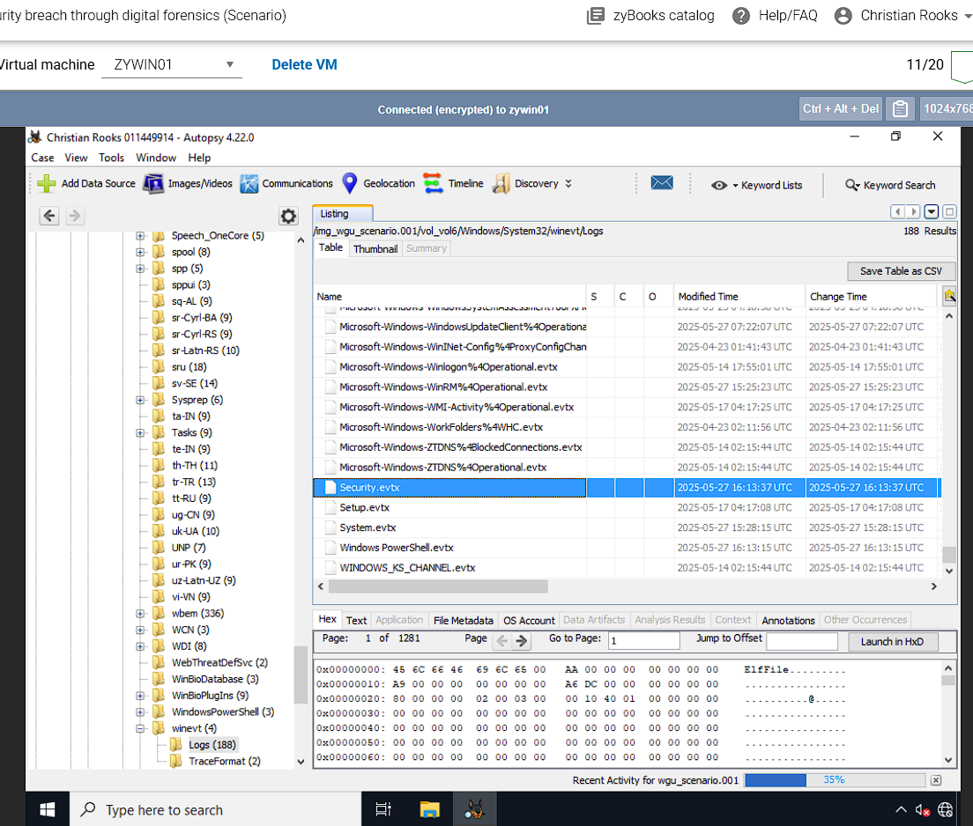

I went to ‘Windows-System32-winevt-logs’, found ‘Security.evtx’, Extracted Files to ‘Desktop’.

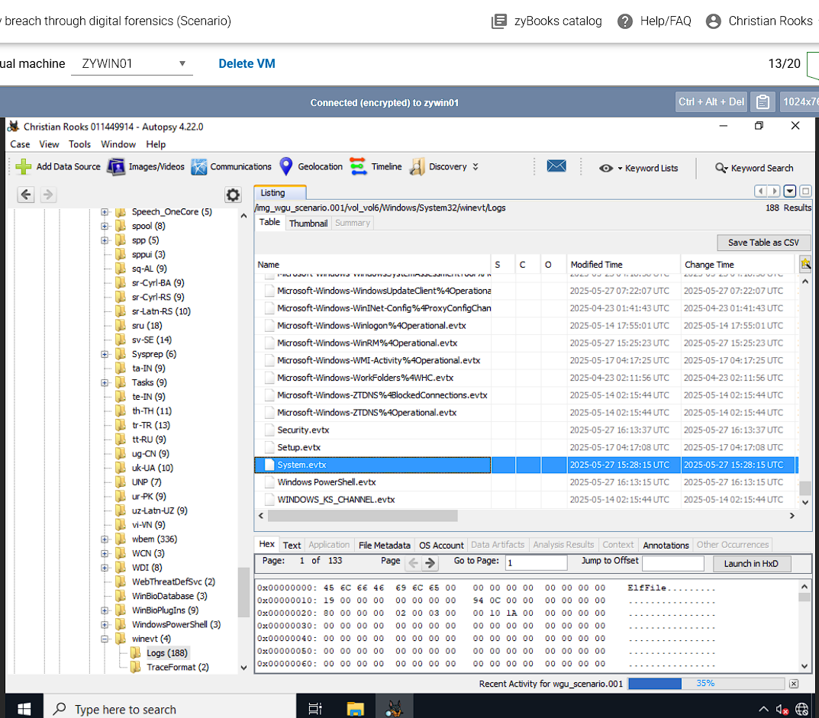

I went to ‘Windows-System32-winevt-logs’, found ‘System.evtx’, Extracted Files to ‘Desktop’.

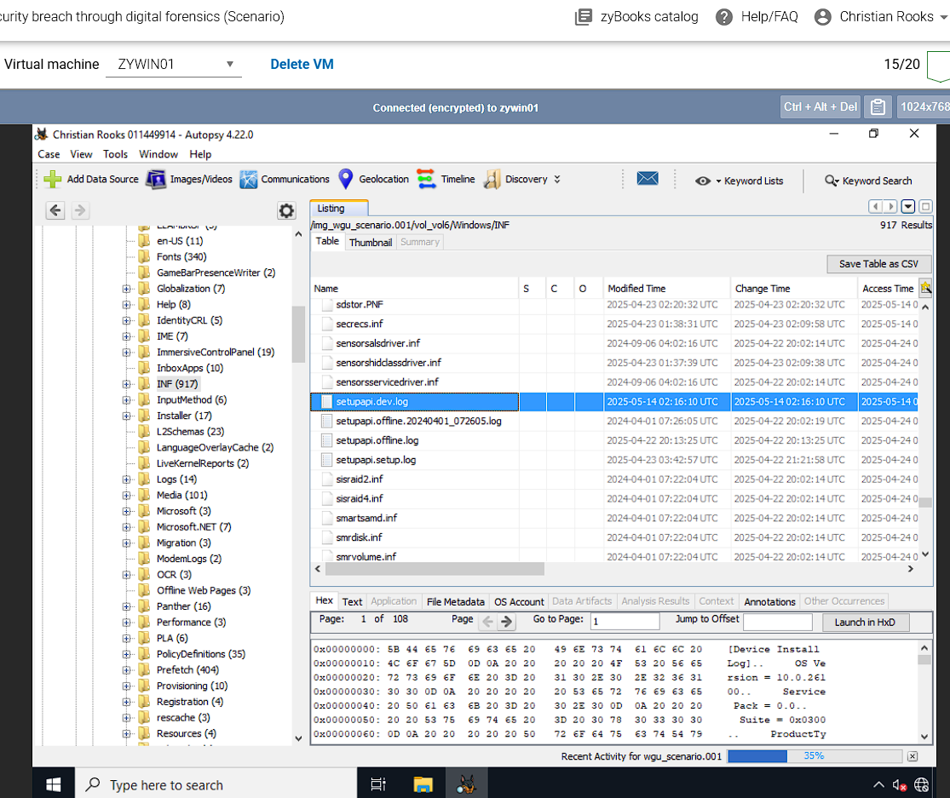

I went to ‘Windows-INF’, found ‘Setupapi.dev.log’, Extracted Files to ‘Desktop’.

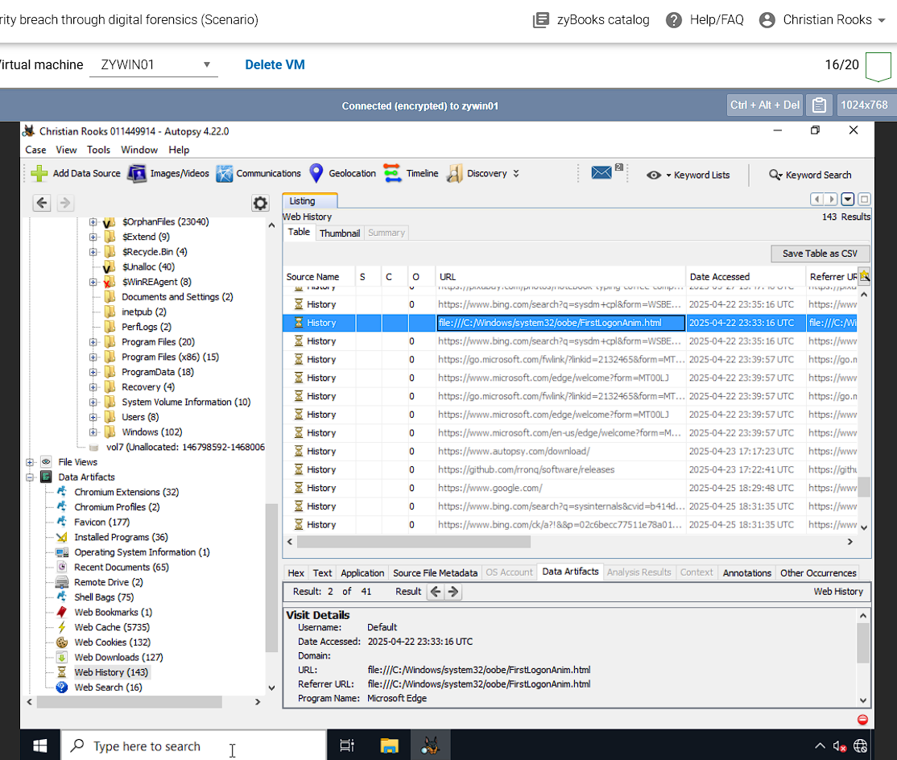

I went to ‘Data Artifacts’ on the left pane, then I went to ‘Web History’, and found ‘file:///C:/Windows/System32’/oobe/FirstLogonAnim.html, then Extracted Files to ‘Desktop’.

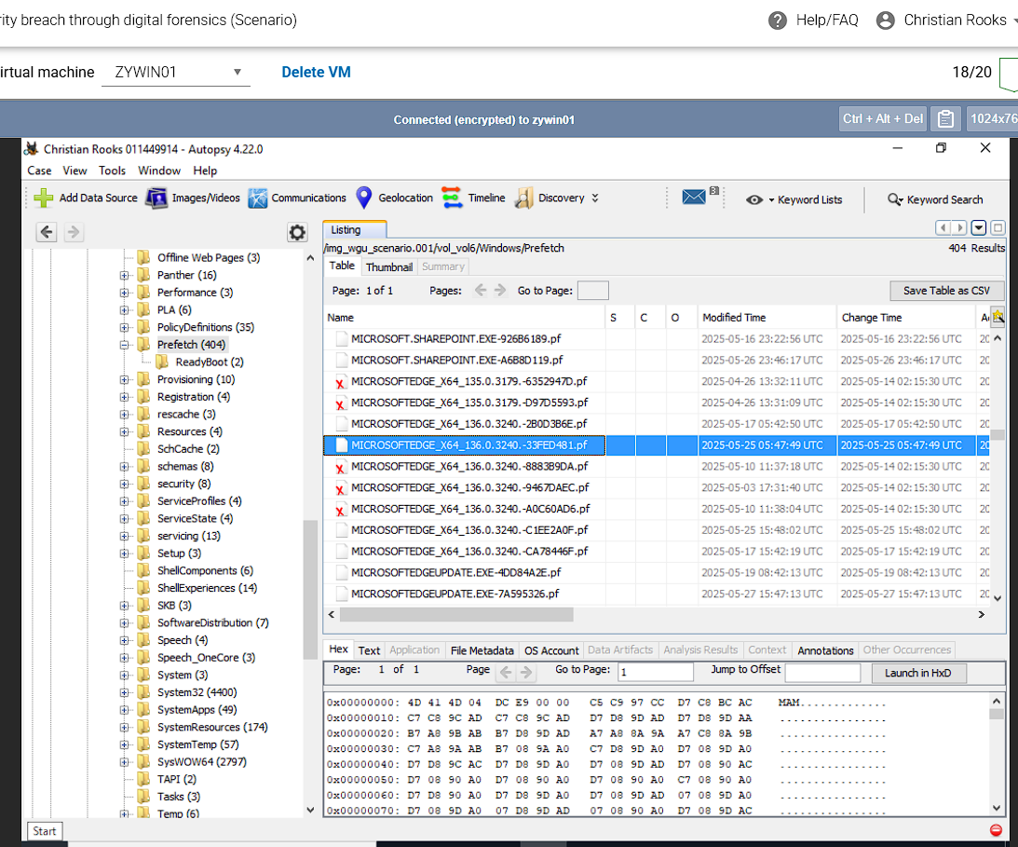

I went to ‘Windows-Prefetch’, and selected file ‘MICROSOFTEDGE_X64_136.0.3240.-33FED481.pf’, and then extracted to ‘Desktop’.

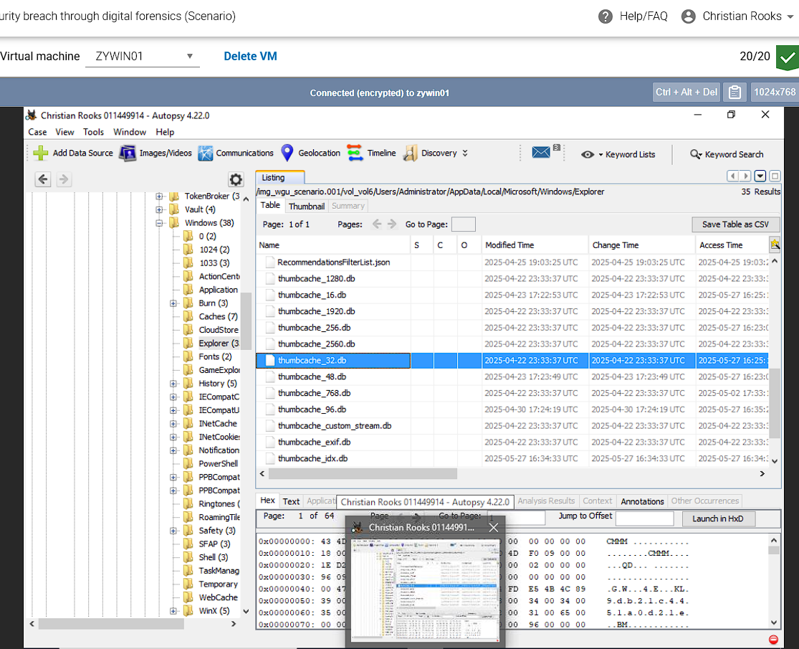

I went to ‘Administrator-AppData-Local-Microsoft-Windows-Explorer’, and then I found file ‘thumbcache_32.db’, I then extracted it to ‘Desktop’.

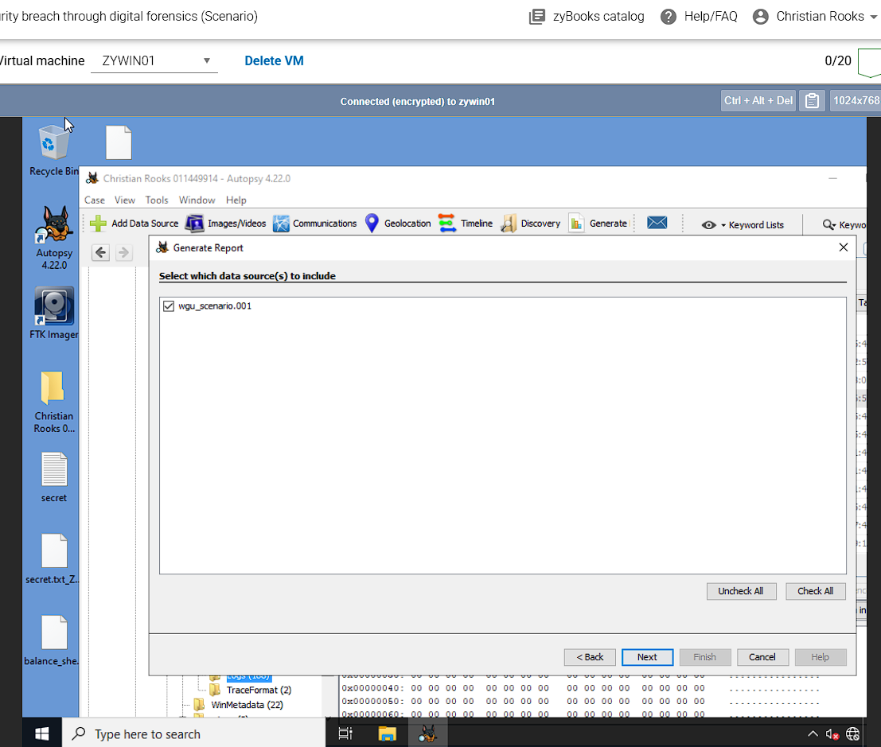

I select ‘tools’ at the top, and then ‘Generate Report’, I select ‘HTML Report’, click ‘Next’, and check ‘wgu_scenario.001’. Click ‘Next’, check ‘All Results’, and ‘Finish’.

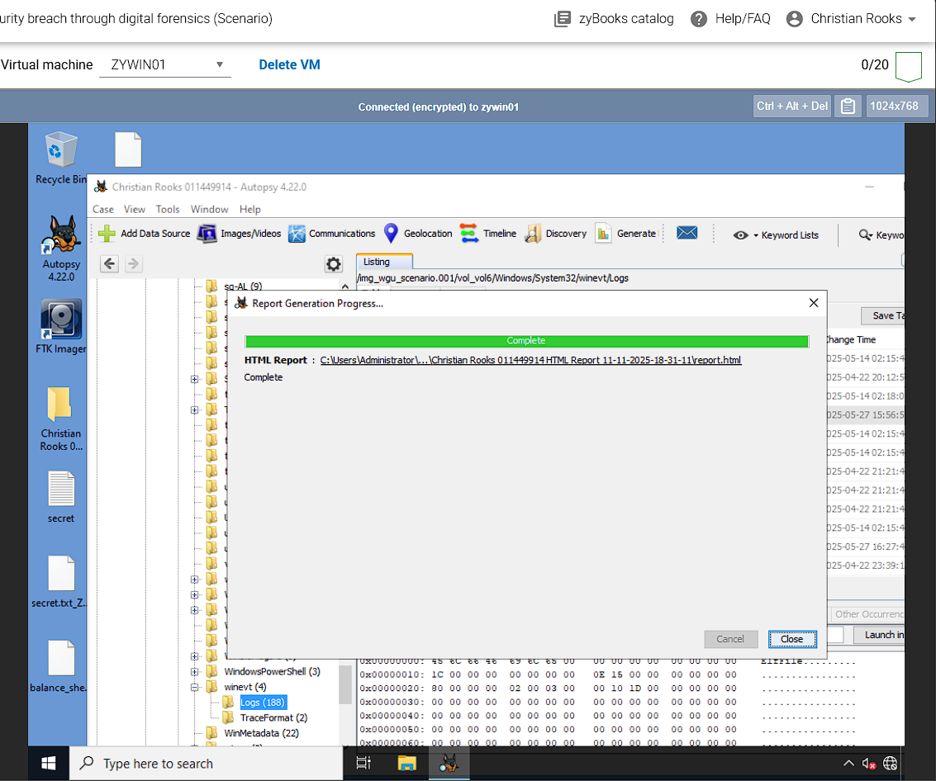

Click the HTML link.

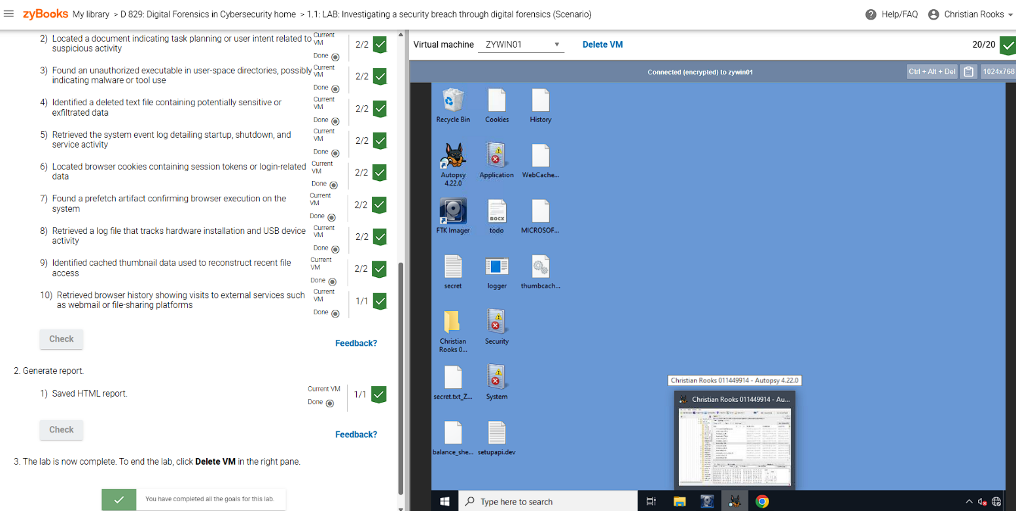

Completed View, and All Evidence.

F.

The key findings from the forensic investigation point to several incidents of unauthorized activity and potential data exfiltration from the suspected Windows 11 workstation at ABC Tech. The most direct evidence of compromise is the recovery of a deleted sensitive file, named secret.txt, from the Administrator-Desktop directory. The contents of this file explicitly stated: "email: hacker123@gmail.com Remember to send confidential information and data to the designated email. Delete any evidence afterwards and make sure to not get caught doing me". This strongly indicates an intent to exfiltrate confidential data and cover up the breach.

Upon​‍​‌‍​‍‌​‍​‌‍​‍‌ further investigation, it was determined that a malicious or unauthorized tool was most probably used, as there was a successful extraction of an executable file named logger.exe from the Downloads folder. The presence of this file indicates that the system was subjected to some kind of monitoring or logging. The retrieval of system activity logs along with application.evtx, Security.evtx, and System.evtx files from the system's event logs, which are very important to establishing a timeline of login attempts, system activity, and suspicious actions, was also accomplished. Besides that, the Setupapi.dev.log was gotten which is basically a file that keeps track of hardware installation and USB device activity and is therefore very important in the case of determining whether or not an external storage device was used for data ​‍​‌‍​‍‌​‍​‌‍​‍‌transfer.

Browser​‍​‌‍​‍‌​‍​‌‍​‍‌ artifacts supported the system's operation, along with the removal of Cookies from the Microsoft Edge browser path, which is able to store session tokens and other login-related information. The prefetch file MICROSOFTEDGE_X64_136.0.3240.-33FED481.pf was obtained to confirm the browser launch. In addition, some other possibly sensitive pieces of information like balance_sheet.xlsx and todo.docx were removed from the Downloads and Documents folders, respectively. Besides, the extracted thumbnail cache (thumbcache_32.db) will also be able to reconstruct the most recent file access, even for files that have been permanently ​‍​‌‍​‍‌​‍​‌‍​‍‌deleted

G.

The​‍​‌‍​‍‌​‍​‌‍​‍‌ evidence revealed by the forensic investigation are a strong indication that the policy violations in the case of the illegal access and spreading of ABC Tech's confidential information might have happened. Most of it is demonstrated by the information about the unapproved data management and the department's misuse for some non-business ​‍​‌‍​‍‌​‍​‌‍​‍‌activities.

The most direct evidence of a severe violation is the recovery of the deleted sensitive file, secret.txt, from the Administrator-Desktop directory. The contents of this file explicitly stated: "email: hacker123@gmail.com Remember to send confidential information and data to the designated email. Delete any evidence afterwards and make sure to not get caught doing me". This text constitutes a clear admission and plan to disseminate confidential data to an external, unauthorized email address, which breaches the company's Data Retention and Handling Policies and potentially the Acceptable Use Policy. Furthermore, the planned deletion of evidence, as explicitly stated in the file, is itself an act of concealment that would impede the investigation mandated by the Incident Response Plan.

Additional evidence supporting policy violations includes the presence and extraction of the executable file, logger.exe, from the Downloads directory. The use of an executable not approved for business purposes suggests the installation and potential use of an unauthorized tool on the corporate Windows 11 workstation, thereby violating the AUP. Finally, the recovery of other potentially sensitive corporate files, such as balance_sheet.xlsx and todo.docx, indicates unauthorized access to and possible manipulation of proprietary information. If the breached data includes financial consumer data, the actions could also potentially violate the Sarbanes-Oxley Act (SOX) if ABC Tech is a listed corporation (Sarbanes-Oxley Act of 2002).

Citations

Cal. Civ. Code § 1798.100 et seq. (West 2023).

Gramm-Leach-Bliley Act, 15 U.S.C. §§ 6801–6809 (1999).

Health Insurance Portability and Accountability Act of 1996, 42 U.S.C. § 1320d et seq. (1996).

H.R. 3763 – Sarbanes-Oxley Act of 2002

International Organization for Standardization (ISO) and International Electrotechnical Commission (IEC). (2015). Information technology—Security techniques—Incident investigation principles and processes (ISO/IEC Standard No. 27043:2015).

Kent, K., Chevalier, S., Grance, T., & Dang, H. (2006). Guide to integrating forensic techniques into incident response (NIST Special Publication 800-86). National Institute of Standards and Technology. https://doi.org/10.6028/NIST.SP.800-86

Regulation (EU) 2016/679 on the protection of natural persons with regard to the processing of personal data and on the free movement of such data (General Data Protection Regulation), 2016 O.J. (L 119) 1–88.